**Total orders placed per year across different states**

with cte as(

Select a.customer_state,datepart(year,b.order_delivered_customer_date) as year,count(*) as total_orders from customers a

Join orders b

On a.customer_id = b.customer_id

Group by a.customer_state,datepart(year,b.order_delivered_customer_date)

having datepart(year,b.order_delivered_customer_date) = 2016 or datepart(year,b.order_delivered_customer_date) = 2017 or datepart(year,b.order_delivered_customer_date) = 2018

)

select customer_state,

sum(case when year = 2016 then total_orders end) as '2016',

sum(case when year = 2017 then total_orders end) as '2017',

sum(case when year = 2018 then total_orders end) as '2018'

from cte

group by customer_state;

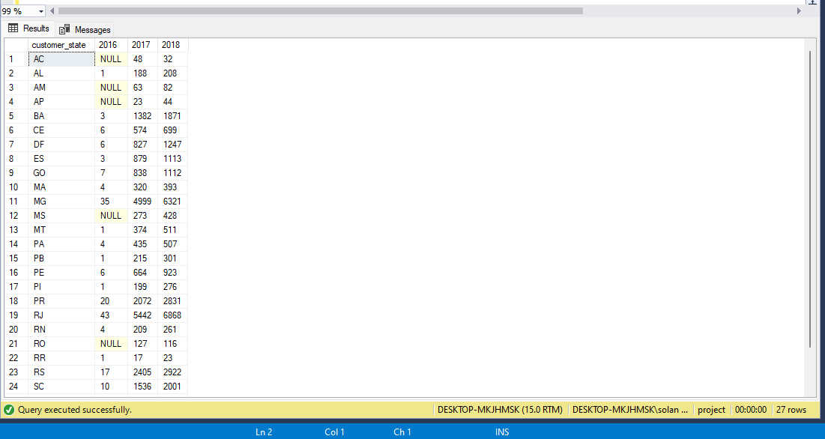

**Customer acquisition per year across different states**

with cte as

(select b.customer_state,datepart(year, a.order_estimated_delivery_date) as year, count(distinct a.customer_id) as Customer_acq from orders a

join customers b

on a.customer_id = b.customer_id

group by b.customer_state,datepart(year, a.order_estimated_delivery_date)

)

select customer_state,

sum(case when year = 2016 then Customer_acq end) as '2016',

sum(case when year = 2017 then Customer_acq end) as '2017',

sum(case when year = 2018 then Customer_acq end) as '2018'

from cte

group by customer_state;

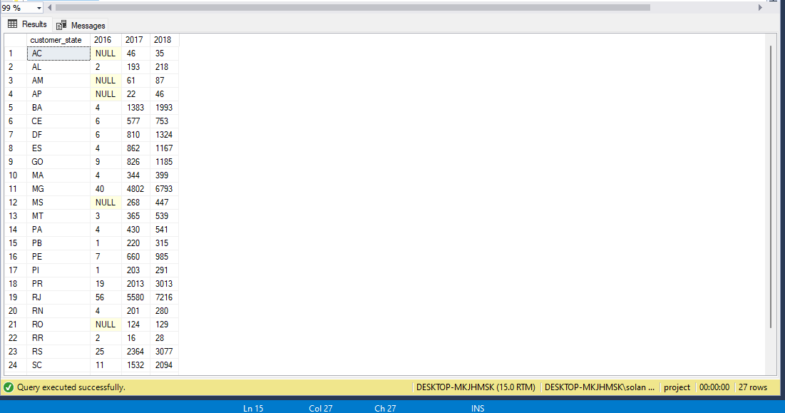

**The top 2 states with declining trends are:**

**AC and RO**

**The top 2 states with increasing trends are:**

**RJ and SP**

**Average review per year for the 4 states mentioned**

with cte as

(select c.customer_state,avg(a.review_score) as avg_review,datepart(year,b.order_delivered_customer_date) as year

from reviews a

Join orders b

On a.order_id = b.order_id

Join customers c

On b.customer_id = c.customer_id

Group by c.customer_state,datepart(year,b.order_delivered_customer_date)

)

select customer_state,

avg(case when year = 2016 then avg_review end) as '2016',

avg(case when year = 2017 then avg_review end) as '2017',

avg(case when year = 2018 then avg_review end) as '2018'

from cte

group by customer_state

having customer_state = 'AC' or customer_state = 'RO' or customer_state = 'SP' or customer_state = 'RJ';

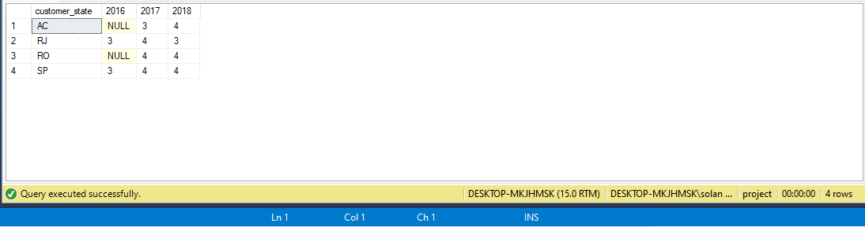

**Analysis of orders received and not received for the 4 mentioned state:**

select count(*) as delivered from orders a

join customers b

On a.customer_id = b.customer_id

where order_status = 'delivered' and b.customer_state like 'AC';

select count(*) as delivered from orders a

join customers b

On a.customer_id = b.customer_id

where order_status = 'delivered' and b.customer_state like 'RO';

select count(*) as delivered from orders a

join customers b

On a.customer_id = b.customer_id

where order_status = 'delivered' and b.customer_state like 'RJ';

select count(*) as delivered from orders a

join customers b

On a.customer_id = b.customer_id

where order_status = 'delivered' and b.customer_state like 'SP';

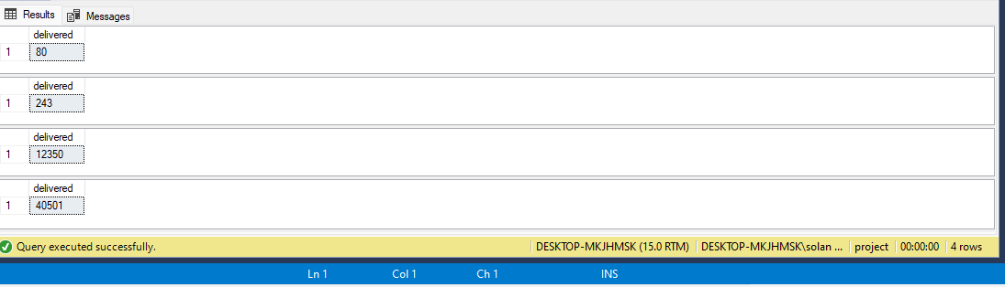

select count(*) as not_delivered from orders a

join customers b

On a.customer_id = b.customer_id

where order_status <> 'delivered' and b.customer_state like 'AC';

select count(*) as not_delivered from orders a

join customers b

On a.customer_id = b.customer_id

where order_status <> 'delivered' and b.customer_state like 'RO';

select count(*) as not_delivered from orders a

join customers b

On a.customer_id = b.customer_id

where order_status <> 'delivered' and b.customer_state like 'RJ';

select count(*) as not_delivered from orders a

join customers b

On a.customer_id = b.customer_id

where order_status <> 'delivered' and b.customer_state like 'SP';

